Reducing Age Bias in Machine Learning
An Algorithmic Approach
Adriana Solange Garcia de Alford1, Steven Hayden1,
Nicole Wittlin¹, Amy Atwood²
1 Master of Science in Data Science, Southern Methodist University,
Dallas, TX 75275 USA
2 T-Mobile, 3255 160th Avenue SE,
Bellevue, WA 98008 USA
{sgarciadealford, skhayden, nwittlin}@smu.edu
{steven.hayden, amy.atwood}@t-mobile.com

Abstract. In this paper, we study the prevalence of bias in machine learning; we explore the life cycle phases where bias is potentially introduced into a machine learning model; and lastly, we present how Adversarial Learning can be leveraged to remove unwanted bias and unfair behavior from a machine learning algorithm. This study focuses particularly on the topics of age bias in predicting employee attrition, where the goal is to present a practical approach to of how age bias can be minimized utilizing Adversarial Learning. SENTENCE FOR RESULTS AND CONCLUSION.

1 Introduction
In today’s age of Big Data, data are driving decision-making in almost every field imaginable. At the foundation of this decision-making is a wide range of algorithms churning through endless data to determine if an individual might be a good employee, a worthy loan candidate, a possible repeat criminal, or the university’s next star graduate. But how are these decisions made? What criteria are considered? What if the outcomes are biased?
These algorithmic processes may seem like black box magic, but there are increasing trends to bring the work out of the shadows and assess machine learning for bias and fairness, as well as accuracy and efficiency. In fact, over the last few years, “the majority of the machine learning community is finally publicly acknowledging the prevalence and consequences of bias in machine learning models” \cite{xu_2019}.
Many widely studied and cited examples of bias in machine learning highlight disparity based on race and sex. One of the most frequently noted examples of biased machine learning is COMPAS, a regression model used by judges to predict if a perpetrator was likely to recidivate. The model was proven to double the predicted false positives for recidivism for African American ethnicities than for Caucasian ethnicities \cite{mckenna_2019}. Another example from 2018 was discovered in Amazon’s machine learning model built to evaluate candidate resumes for software engineering roles, where the algorithm explicitly penalized resumes with the word “women’s” and downgraded candidates from two all-women’s colleges \cite{kearns2019ethical}.
Research teams and practitioners have been exploring approaches, techniques, and models to account for and mitigate bias in machine learning in recent years. One intriguing option is the use of adversarial learning. Our team will utilize two competing adversarial models – similar in nature to GANs (generative adversarial networks) \cite{goodfellow2014generative} – to reduce age bias in a sample data set related to a common human resources business problem.
In the domain of human resources, employee attrition garners significant attention. The driving factors of employee attrition have been well studied, and the goal of this work is not to duplicate those efforts. Instead, we seek to explore how age may be influencing employee attrition and whether adversarial learning can reduce bias related to age when predicting if employees will stay or leave a company. The data set we will use is the IBM Employee Attrition, found on Kaggle.
Age, similar to race and sex, is considered a protected class and should not legally be used as an influential factor in many situations, particularly those related to employment and the workplace. Yet, the Equal Employment Opportunity Commission (EEOC) acknowledges that “research on ageist stereotypes demonstrates that most people have specific negative beliefs about aging and that most of those beliefs are inaccurate. These stereotypes often may be applied to older workers, leading to negative evaluations and/or firing, rather than coaching and retraining” \cite{lipnic}.
PLACEHOLDER – for results
PLACEHOLDER – for conclusion
2 Related Research

Overview of Bias in Machine Learning
The concept of bias – and fairness as a related topic – have been studied extensively for decades in philosophy and psychology, well “before computer science started exploring it” \cite{rubenstein2018surveying}. While there is no universal, commonly accepted definition of fairness, bias tends to be a more concrete idea. **ADD RELATIONSHIP OF BIAS AND FAIRNESS HERE … particularly when noting how different preferences, outcomes, and cultural contexts need to be considered. However, at a most basic level, fairness can be broken into “individual fairness,” where similar individuals are treated the same, and “group fairness,” where different groups should be treated equally. Therefore, bias can be defined as a personal and sometimes unreasoned judgement \cite{merriam-webster} that can impede fairness from being achieved. For the purposes of this paper, these definitions are a good starting point.

In the last few years, understanding bias in the context of machine learning has become a more widely discussed topic. One goal in machine learning work is to strive for the highest accuracy possible. But even with good accuracy, has consideration been given to it could impact the populations (or subpopulations) the work is intended to serve or reflect? A well-documented example is COMPAS, which upon further examination was found to double predicted false positives for recidivism for African American ethnicities. The developers did not set out to create a biased system, but it was an unfair and unanticipated outcome.

When defining a question or problem, IBM’s AI Fairness 360 toolkit – an open source software toolkit that can help detect and remove bias in machine learning models – recommends three key questions to consider: what type of fairness is trying to be achieved; what are appropriate tools and metrics depending on the type of fairness and the data; and what algorithms to use \cite{ibm360}.

Simply removing the “protected variable,” say race, gender, or age, from the data will not yield a debiased machine learning model. In fact, because other variables can be highly correlated with the protected variables and serve as proxy data, a model could even amplify bias \cite{lum2016statistical}. It is important to understand where bias may be introduced in the machine learning process and appropriate metrics to measure bias and fairness.

There are three points in the machine learning pipeline where bias can be addressed: during the data collection and preprocessing; during the selection and creation of models; and when implementing results. There are opportunities to intervene at each of these points to mitigate bias. It is recommended that intervention occur as early in the machine learning process as possible, but it will depend on the answers to the questions about fairness and the specific data set \cite{ibm360}.

The IBM AI 360 tool kit offers a good visual to understand the overall process and points for intervention. See figure \ref{fig:RelatedFig}. The first intervention point is during preprocessing. Often this relates to the origin of the data and how it was collected or sampled. For example, groups may be excluded or under represented based on population characteristics. Older generation may utilize social media less than younger adults, so sampling from social media would under sample the older generation compared to the rest of the population. Understanding population distributions and protected groups (or protected attributes) will dictate how to make adjustments, such as resampling or collecting more data, during the preprocessing stage. Preprocessing intervention modifies the training data in an attempt to mitigate bias.
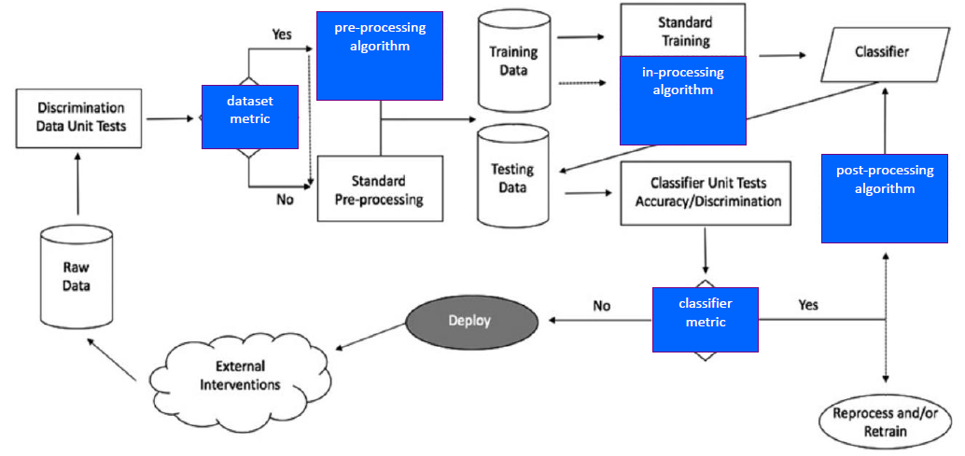
Figure 1. This flowchart depicts three (3) stages in the life cycle of a machine learning model - preprocessing, in-processing and post-processing - where intervention could mitigate bias in the model (from IBM AI Fairness 360 toolkit)

When preprocessing is not an option, it may be necessary to rely on techniques to implement during the machine learning process (known as “in process”). This stage seeks to modify the learning algorithms to remove bias or discrimination during the training process, often by changing the objective function or imposing a new constraint \cite{rubenstein2018surveying}. Of particular interest to this team is the use of adversarial networks, where an adversarial algorithm attempts to remove bias during the training process.

In situations where the machine learning process takes place in a “black box” with no opportunity to intervene in the data or the algorithms, postprocessing techniques can be an option. At this stage, the model training is complete, so a bias mitigation algorithm could be applied to the resulting predicted labels. This intervention would occur before implementation of the model, and the data scientist needs to consider the impact of the results.

Overview of Employee Attrition Research
The topics of employee turnover and factors influencing attrition are well-studied by both the research community and human resources (HR) practitioners. To understand the evolution of the field, Hom, Lee, Shaw, and Hausknecht \cite{hom2017one} conducted a comprehensive and systematic review of the most seminal publications about employee turnover in the Journal of Applied Psychology over the last 100 years. Additionally, they assessed other key theoretical and methodological contributions to the field as part of the review.
Since 2000 and forward, 21st century theory and research has focused on: the idea of embeddedness, or factors and forces influencing attrition; the evolution of the job search process; the influences of employee-organization relationships and HR management systems on collective turnover; the impact of HR practices on good-performers vs bad-performers; and the relationship of collective turnover on organizational performance. The field also saw “significant scholarly attention to employee turnover at the group, team, work unit, and organizational levels” \cite{hom2017one}.
With a basic, foundational understanding of the field of employee attrition, the team turned to exploring common predictors of turnover. Rubenstein, Eblerly, Lee, and Mitchell followed up the comprehensive work of Hom et al. to “assess the progress made in research on voluntary employee turnover” \cite{rubenstein2018surveying}. The aspect of their work that is of most interest to this team is understanding the predictors of employee attrition, especially related to the role of age.
Rubenstein, et all, explored 57 predictors across 1,800 side effects (drawn from a study population of 316 articles). They categorized these specific predictors into several groups: individual attribute predictors (tenure, age, conscientiousness); job aspects (characteristics, security, complexity, as well as traditional characteristics of pay, role ambiguity, role conflict); traditional job attitudes (involvement, satisfaction); newer personal conditions (coping, stress); organizational context (climate, size, prestige); person-context interface (fit, influence, peer/group relations); existing job market (alternatives); attitudinal withdrawal; and employee behavior (absenteeism, performance).
This team also reviewed an article in the SMU Data Science Journal authored by fellow graduate students in April 2018. They conducted an analysis on two distinct data sets to determine the predictors of employee attrition in those two populations. The first data set was anonymized information from the U.S. Office of Personnel Management (OPM), reflecting a full year of separation data from October 2014 and September 2015. Attributes of particular interest in this data set were: age data group, captured categorically in 5-year increments; a lower limit age (lower bound for age); and years to retirement (based on the Federal Employee Retirement system eligibility base of 57 years old). The features of the final model with best prediction accuracy included: lower age limit; length of service; various age bins (age 20-24, 40-44, 45-49, 50-54, or 55-59). They also utilized IBM HR Analytics Employee Attrition & Performance data, a fictional data set created by IBM data scientists, to compare the strongest features of that set with the features selected in the OPM model. Ultimately, the model results were comparable for both sets of data with the relationship between length of service, pay scale, and age being strong predictors; however, the IBM data highlighted nuances missed by the OPM data related to measuring job satisfaction, work-life balance, and engagement. \cite{frye2018employee}
From this background, it is evident that age does play a role in employee attrition; our team seeks to understand impact of this and assess whether or not age bias may be causing undue influence in predicting attrition. The goal of the work described in this paper is not to predict employee attrition, per say, but rather to show how age bias could be reduced through adversarial learning models when attempting to predict attrition.

Understanding the Current Landscape
The urgency of issues surrounding age bias is magnified by understanding today’s employee landscape. In 2018, “the Bureau of Labor Statistics estimated that the oldest segments of the workforce – those ages 65 to 74 and 75 and older – are expected to increase the fastest through 2024. This oldest cohort of workers of age 65+ workers is projected to grow by 75 percent by 2050, while the group of workers age 25 to 54 is only expected to grow by 2 percent over this same period” \cite{lipnic}. The lack of mixed-age teams and reverse-age mentoring, coupled with age stereotypes and bias, can cause varying degrees of tension in the workplace between the generations. Ultimately, our goal is to simulate exploring age bias within the context of employee attrition and demonstrate how an adversarial learning methodology could reduce bias.

3 Understanding Generative Adversarial Networks (GANs)
There have been many techniques, such as Deep Neural Networks, Generative Adversarial Networks (GAN), and Convolutional Neural Network, used to classify images \cite{gu2019improve}. One technique – GAN – stands out in image classification and is the foundation for this paper’s approach to reduce bias. In 2014, Ian Goodfellow and his colleges proposed a new framework to estimate generative models (a model that includes the distribution of the data itself and the likelihood a given example) via an adversarial process, in which two models are trained simultaneously: a generative model G that captures the data distribution, and a discriminative model D that estimates the probability that a sample came from the training data rather than G. \cite{goodfellow2014generative} The adversarial framework makes this classification into a supervised machine learning model, since it knows if the data is real or fake. 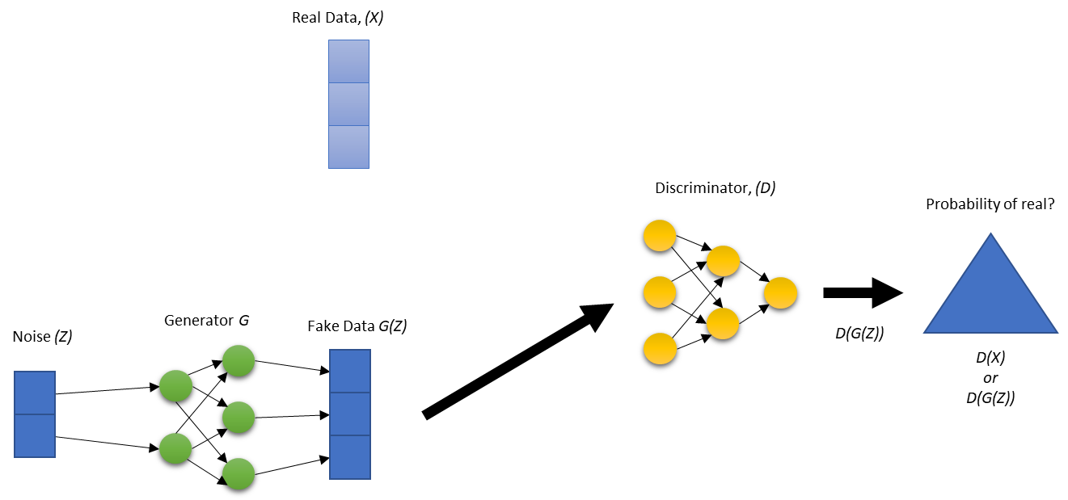Figure 4.1

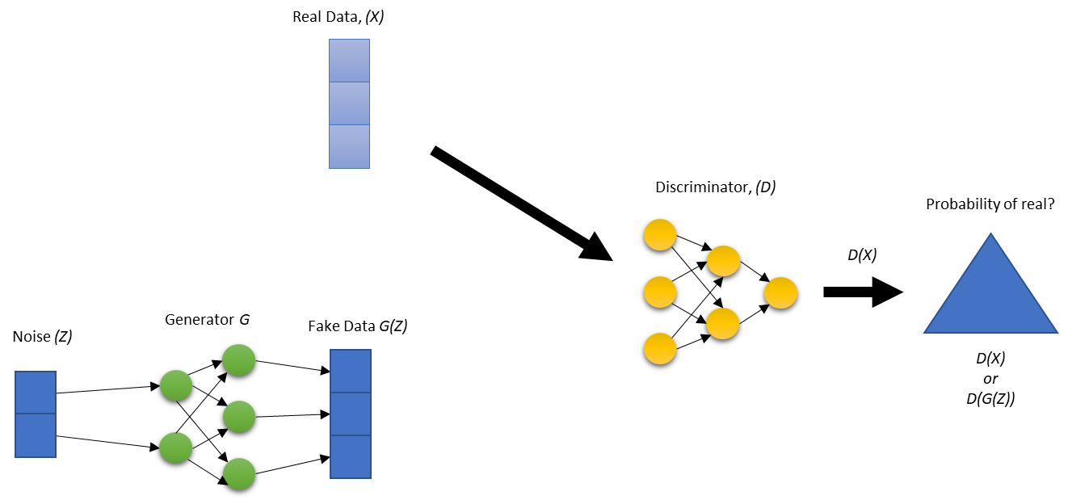 Figure 4.2

Figure \ref{fig:GANs1} and figure \ref{fig:GANs2} illustrate the basic structure of GANs in two steps that happen simultaneously. For explanation purposes, each step is described separately. In figure \ref{fig:GANs1}, the distribution of the real data set is used to generate a fake data set by combining real data and noise, through generator (\emph{G}) algorithm thus, the vector size is the same for both G(\emph{Z}) and Real Data(\emph{X}). Once it is done generating fake data, it passes Fake Data G(\emph{Z}) to the discriminator (\emph{D}). The discriminator (\emph{D}) is a classification algorithm used to determine if the data came from Fake Data G(\emph{Z}) or Real Data(\emph{X}). Figure \ref{fig:GANs2} is the same, but this time the real data (\emph{X}) gets passed to the discriminator (\emph{D}).
The discriminator (\emph{D}) and the generator (\emph{G}) update their parameters iteratively, based on a loss function (explained below) and through back propagation. Back propagation is the process of modifying the parameters (weights) of the network between neurons, so the next iteration is more accurate. If the discriminator (\emph{D}) classified the data correctly as real or fake then the generator (G) gets updated. If the discriminator (\emph{D}) incorrectly classified the data real or fake, then the discriminator (\emph{D}) gets updated.

\begin{equation}
\label{eq:GAN}
V(D,G)=E_{x~P_{data(x)}}[log D(x)]+E_{z~P_{z(z)}}[log(1-D(G(z)))]
\end{equation}
Equation 1 describes the loss function. The first term $E_{x~P_{data(x)}}[log D(x)]$ represents an expected output of the log of discriminator (\emph{G}) when the input is from the real data. The second term $E_{z~P_{z(z)}}[log(1-D(G(z)))]$ is the expected value of the log of the quantity of 1 minus the discriminator (\emph{G}), which is making predictions about the fake samples. This function makes the generator (\emph{G}) want to minimize the G(\emph{Z}) and the discriminator (\emph{D}) maximize it. The conflicting elements of this function make the generator (\emph{G}) seek to maximize G(\emph{Z}) while the discriminator (\emph{D}) works to minimize G(\emph{Z}). This creates the adversarial “game.”
To train the discriminator (\emph{D}), the process loops through the data created by the generator (\emph{G}) and the real data \emph{k} times before the generator (\emph{G}) is updated. This allows the discriminator (\emph{D}) to optimize given \emph{k}, where \emph{k} is a parameter chosen prior to training. GANs use the gradient of the loss function to change the parameters of the discriminator (\emph{D}) to maximize the loss function that sets up the optimization between both models.
Training the generator (\emph{G}) takes noise data and then transforms it to get the fake data for \emph{k} times. This time it allows the generator (\emph{G}) to optimize given \emph{k}. The gradient of the loss function is then used to change the parameters of the generator (\emph{G}) to minimize the loss function. This is a complete iteration of training a GAN model.
Goodfellow also also discussed when to stop training the model. Once the discriminator (\emph{D}) consistently cannot distinguish between fake or real data then training is done. In other words, once the distribution of the generator (\emph{G}) matches the real data. \cite{goodfellow2014generative} The discriminator algorithm can then be implemented in the desired tool for classifying.
4 Data Set: IBM Employee Attrition Data
A best practice in the lifecycle of a machine learning model is to start with exploratory data analysis (EDA), with the objective of extracting information that unveils trends, feature correlation, group distributions, demographics, and biases, among other characteristics. For this paper, the intent is to explore how age impacts the prediction of employee attrition and mitigate any age bias present in the modeling.
From the related research, we knew that age did have an impact on employee attrition. Given the trends noted by the EECO, we anticipate that attrition may increase with age. Additionally, we believe that the attrition rate should be approximately equal across all age groups; therefore, we are looking for evidence that age bias may be occurring more frequently with older employees.

The data set used for this exploration is fictious employee data simulated by IBM data scientists to represent employee attrition and performance \cite{rohan}. There are approximately 1,470 entries representing a specific employee, with 35 descriptive features, where ‘Attrition’ is the dependent, target feature. We are treating ‘Age’ as a protected variable as it should not have undue influence when predicting age.

In the data set, 1,233 employees are classified as “no” with regards to attrition, meaning they remained at the company, and the remaining 237 (with “yes) did leave. This breakdown of 84% remaining vs 16% departing is in line with what we anticipated, and we will be cognizant of the imbalanced distribution as we proceed with the analysis.

Next, we explored attrition across age range, in one-year, five-year and 10-year increments. The five- and 10- year increments are most useful for our purposes. At both ends of the age distribution, there were fewer records (i.e. age 18-19 reflected 17 employees; only five employees were age 60.) Therefore, we combined the youngest employees as 25 and under and the oldest employees as above 50 for analysis purposes. The distribution of employees in this data set generally follow a normal distribution, with a slight right skew toward younger employees, as illustrated in Figure ???. The green segments of the chart indicate the employees that did leave (attrition = yes).

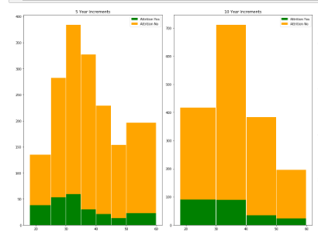
** How can we get the visual clearer?
** Needs caption

Then, we looked at the percentage of attrition by age group in both five-year and 10-year increments. Contrary to our initial thinking, attrition appears to decrease as employees age. **WHY IS THIS IMPORTANT??

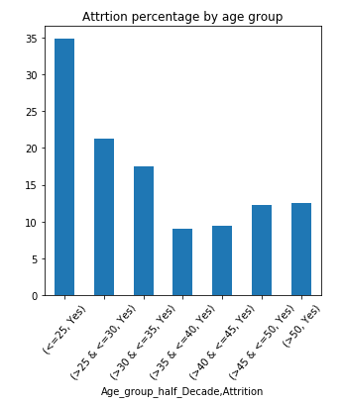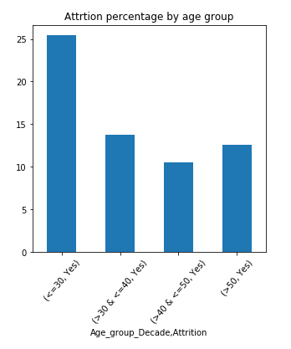

Finally, the team explored a correlation matrix of the data set to understand the relationships between variables, particularly age. In Figure ??, positive correlation is displayed in blue, and negative correlation is displayed in red. We observed that employee age is strongly related to: job level, monthly income, total number of working years, the number of years worked at the company, and number of companies he or she has worked at. A weaker relationship exists between age and educational level, number of years in the current role, number of years since last promotion and number of years with current manager. The correlation matrix also reinforces the inverse relationship between age to attrition seen in the histograms: older employees show lower levels of attrition while young groups demonstrate higher levels. These insights are critical to understand as we conduct further analysis as bias can be amplified through proxy variables that encode similar information to the protected attribute.

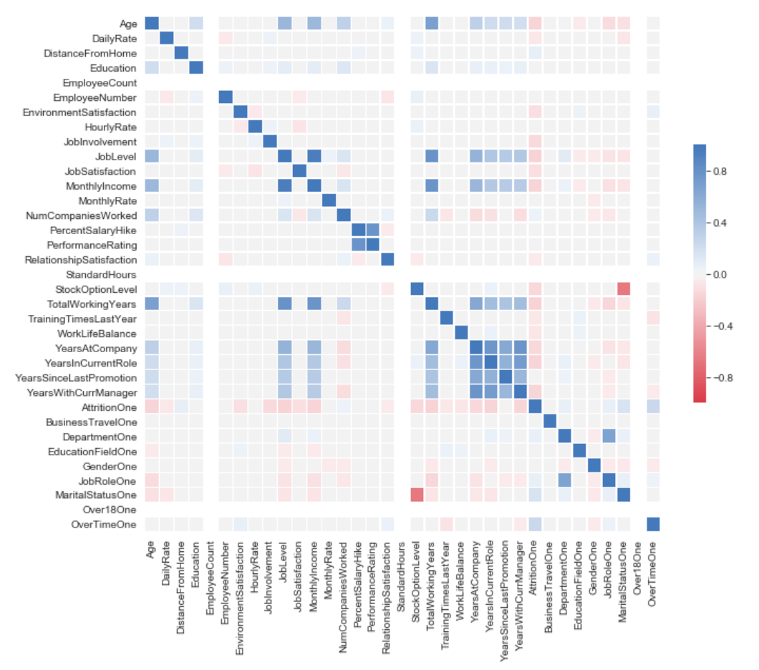

\begin{enumerate}
\item EDA was executed in Python language and libraries.
\item The Python Jupyter notebook is found in the project’s GitHub URL: \url{https://github.com/skhayden/SMU-Capstone-Age-Bias-in-Predictive-Modeling-.git}.
\item Data was extracted in Excel format and converted to CSV format.
\item The data was loaded into a Data Frame to calculate simple statistics for all features.
\item Explored the protected Age feature by finding unique age value counts and producing a bar chart to learn the distribution of the employees ages.
\item Calculated categorical frequency grouping counts to unveil trends and distributions; for example, 1,043 employees out of the 1,470 total employees rarely traveled. This type of frequency groupings is useful to unveil insights and important relationship within the data.
\item As a simplification step, the levels on the ‘Education’ feature were reduced from 5 to 4 by combining levels 4 and 5, since level 5 had a reduced number of employees.
\item The data set was one-hot encoded (and original features were removed) to prepare the data as input to the:
\begin{enumerate}
\item Machine learning model
\item Correlation matrix function
\end{enumerate}
\item A correlation matrix between features is also provided for analysis purposes.
\item A Matplotlib graph chart of the correlation matrix was built for easy visualization.

\end{enumerate}

- Exploration of the protected feature, Age:
  - Found unique age value counts
  - Produced several histograms as visualizations to gain insight on the data:
    - Employee counts around employee’s age
    - Employee counts and percentages by age group:
      - Grouped the data in buckets of 10, 5, and 1 years’ increments
        - In some of the histograms and due to a reduced number of employees in certain groups, we combined these data with their closest age group:
          - Employees of age less than 20 were combined with the 20 years of age group.
          - Employees of age 50 and above were combined with the 50 years of age group.

******DRAFT 1 Ends Here******
5 Experiment
The design of our analysis to explore the impact of age on attrition with respect to biased age data is founded on two scenarios. One scenario is to determine if the data used in training a machine learning model to predict attrition contains any age bias. HOW DO WE TELL?? Then, a second scenario will use adversarial learning to mitigate bias due to age as a variable when predicting attrition. The results of these scenarios will be compared to understand how well the adversarial learning “debiasing” technique worked on an employee attrition data set.

Write up the baseline here??
For scenario two, we turned to the work of Zhang et all? that uses the principals of GANs to setup two competing models with the goal to mitigate bias. The original work reduced gender bias in word embeddings and also predicted income as a function of age with the goal of enforcing equality of odds. [ADD BENEFITS OF TECHNIQUE – generality to demo parity, equality of odds, equality of opportunity; model-agnostic, optimality]
Adversarial learning to mitigate bias starts with a model to predict \emph{Y} given explanatory variables \emph{X}. This part of the model is similar to the discriminator(\emph{D}) illustrated above in the GAN overview. The negative of the gradient of the weights $\bigtriangledown_W$ is passed to the adversary model. This model [WHICH MODEL] predicts the protected variable \emph{Z} given \emph{X}. The adversary model is similar to the generator(\emph{G}) that tries to hide the protected variable \emph{Z} \cite{zhang2018mitigating}. [NW Q: isn’t one of these Y_hat? WHICH scenario is our data – that Y_hat and Z are independent for demo parity; Y is discrete and Y_hat satisfies equality of opportunity if Y_hat and Z are independent conditioned on Y=y; Y_hat satisfies quality of odds if Y_hat and Z are conditionally dependent given Y] – MAYBE THIS IS WHERE DEMO PARITY INFO GOES??
**Define LP = loss function for prediction model / LA = loss function for adversary model
\begin{equation}
\label{eq:AdvLoss}
\bigtriangledown_W L_P - proj_{\bigtriangledown_W L_A} \bigtriangledown_W L_P - \alpha \bigtriangledown_W L_A
\end{equation}
The equation \ref{eq:AdvLoss} is the loss function defined in this approach. It is what sets up the adversary feedback between the two models. The first term $\bigtriangledown_W L_P$ is the gradient of weights of the loss for predictor. “The middle term $proj_{\bigtriangledown_W L_A} \bigtriangledown_W L_P$ prevents the predictor from moving in a direction that helps the adversary decrease its loss” \cite{zhang2018mitigating} The last term $\alpha \bigtriangledown_W L_A$ is much like the maximization side of the loss function of the discriminator(\emph{D}).
To provide evidence that the data has been debiased, a logistic regression algorithm is trained on the IBM Employee Attrition Data.

The IBM data will be split into a train and test dataset. An 80/20 train and test split is chosen as it is the standard split in most research. The algorithm is trained using gradient decent. The same way it will be trained when the adversarial algorithm is trained in tandem.

The prediction accuracy is then measured by age groups that were created in the initial data exploration to get base reading on bias in the age groups. The adversarial and prediction algorithms can then be trained to measure the accuracy between the age groups to compare the bias between the two methods.
6 Results

The initial Logistic regression model is trained on all the variables contained in IBM Employee Attrition Data excluding age, the protect variable (\emph{Z}) and the predicted variable (\emph{Y}). The fitted model is then used to predict the test set in order to get an accuracy score. [Also removed attrition?? Since that’s our prediction?]

To achieve demographic parity, the accuracy of the model should be evenly distributed across all the age groups to be fair. The results from the model trained on the IBM data shows an uneven distribution of the accuracy as seen in table(Some number) Age groups less than 35 have a lower accuracy than age groups older than 35. This could be due a larger population and the percentage of attrition in the older age groups are is much lower as seen in Figure(Some number) …..

Overall accuracy of the model: | 85.9%
Age_group_Decade
# of obs for age group <=30 : | 84.3%
# of obs for age group >40 & <=50 : | 92.1%
# of obs for age group >30 & <=40 : | 81.9%
# of obs for age group >50 : | 97.3%
Age_group_half_Decade
# of obs for age group <=25 : | 76.2%
# of obs for age group >25 & <=30 : | 86.8%
# of obs for age group >30 & <=35 : | 75.0%
# of obs for age group >35 & <=40 : | 91.8%
# of obs for age group >40 & <=45 : | 93.1%
# of obs for age group >45 & <=50 : | 90.3%
# of obs for age group >50 : | 97.3%
The training of the model in tandem with the adversarial algorithm should reduce the bias and the results should appear more evenly distributed.

6 Ethics
- Society context, what impact if not done?
- Context related to language, usability
- What else?

From equality to equity … most literature focused on equality, each individual / group given same amount of resources, attention, outcome. Not much attention to equity, each individual or group given resources needed to succeed. (From A Survey on Fairness and Bias in Machine Learning)

https://blog.insightdatascience.com/tackling-discrimination-in-machine-learning-
5c95fde95e95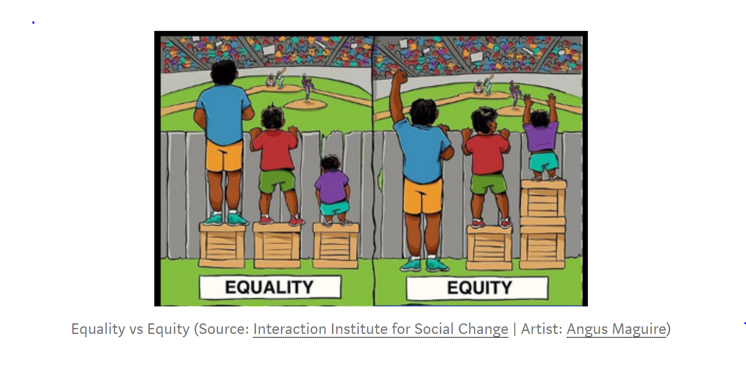
7 Results
8 Conclusions

References
Joyce Xu: https://towardsdatascience.com/algorithmic-solutions-to-algorithmic-bias-aef59eaf6565

Zhang, Lemoine, Mitchell : https://arxiv.org/pdf/1801.07593.pdf (Mitigating Unwanted Biases with Adversarial Learning)

Krishnamurthy: https://towardsdatascience.com/survey-d4f168791e57 (Understanding Data Bias)

[Goodfellow et al. 2014] Goodfellow, I.; Pouget-Abadie, J.; Mirza, M.; Xu, B.; Warde-Farley, D.; Ozair, S.; Courville, A.; and Bengio, Y. 2014. Generative adversarial nets. In Advances in neural information processing systems, 2672– 2680.

Victoria Lipnic, Acting Chair of the US Equal Employment Opportunity Commission; The State of Age Discrimination and Older Workers in the US / 50 Years After the Age Discrimination in Employment Act (ADEA) / June 2018 https://www.eeoc.gov/eeoc/history/adea50th/report.cfm

Weapons of Math Destruction

The Ethical Algorithm

Fair ML

https://aibusiness.com/three-notable-examples-of-ai-bias/

https://arxiv.org/pdf/1606.03490.pdf

Nicole’s References for employee engagement:

Frye, Alex; Boomhower, Christopher; Smith, Michael; Vitovsky, Lindsay; and Fabricant, Stacey (2018) "Employee Attrition: What Makes an Employee Quit?," SMU Data Science Review: Vol. 1 : No. 1 , Article 9.
Available at: https://scholar.smu.edu/datasciencereview/vol1/iss1/9

Rubenstein AL, Eberly MB, Lee TW, Mitchell TR. Surveying the forest: A meta-analysis,
moderator investigation, and future-oriented discussion of the antecedents of voluntary employee turnover.
Personnel Psychology. 2017;00:1–43. https://doi.org/10.1111/peps.12226
Hom, P.W., Lee, T.W., Shaw, J. D., & Hausknecht, J. P. (2017). One hundred years of employee turnover theory and research.
Journal of Applied Psychology. http://psycnet.apa.org/doi/10.1037/apl0000114

Solange References in EDA:
- http://inseaddataanalytics.github.io/INSEADAnalytics/groupprojects/January2018FBL/IBM_Attrition_VSS.html

AI 360 Tool Kit

Slide from Presentation

